East Carolina University

POSTDOC
Applicant Tracking (HIRE)
User’s Guide

(this guide revised by the Office of Postdoctoral Affairs)

November 2024

Table of Contents
POSTDOC Applicant Tracking (HIRE) User’s Guide 1
Table of Contents 2
Overview 3
Create a New Job Posting 3
Complete the Guest User Account 15
Review the Applicant Pool 16
Create the Hiring Proposal 22
Extend an Offer of Employment 24

Overview
The Applicant Tracking module is used to 1) post job vacancies, 2) review the applicant pools and 3) create a hiring proposal for Postdoc positions.

Create a New Job Posting
Step | Action
1 | Log in to People Admin using your PirateID.  Change the module to Applicant Tracking System, if needed.  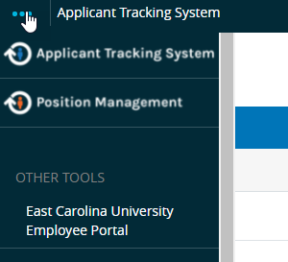
2 | Please note that you do not have to manually change your default user group as you will automatically be redirected when selecting the position from your Inbox.  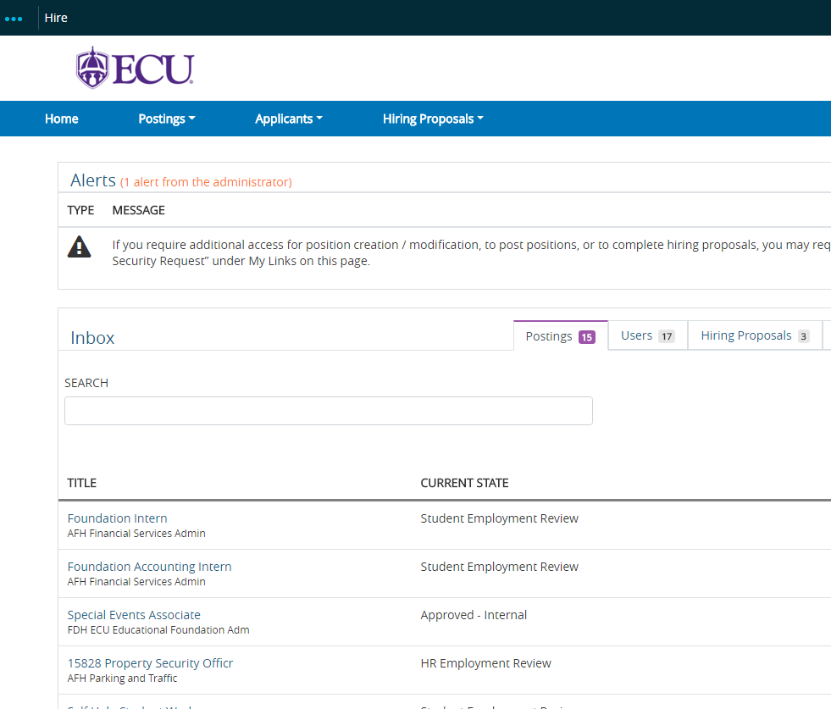  You may continue to manually change your default user group using the instructions provided below.  Change the Default User Group (top right corner) on your home page to Temp/Student/PostDoc/Non PD EHRA Initiator.  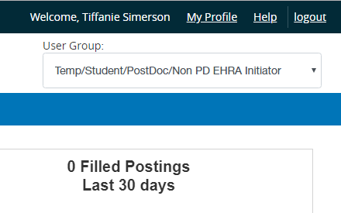
3 | The page should automatically refresh. A blue confirmation message will at the top of the screen.  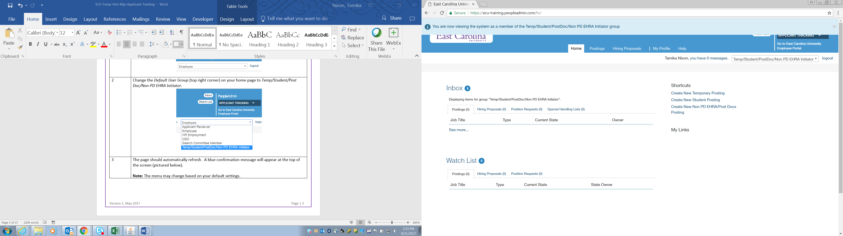  Note: The menu may change based on your default settings.
4 | Click the Postings tab and choose Non PD EHRA/Post Docs, from the drop-down.  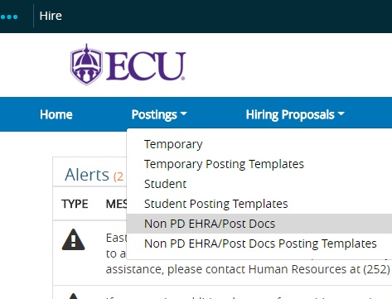
5 | Click Create New Posting. A Create New dialog box opens with multiple options.  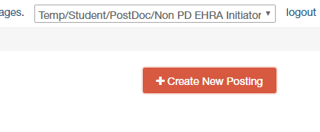
6 | Choose Create from Position Type. You may also select Create from Posting if the position has been posted before or Create from Posting Template if a template has been created.
7 | The New Posting page displays.  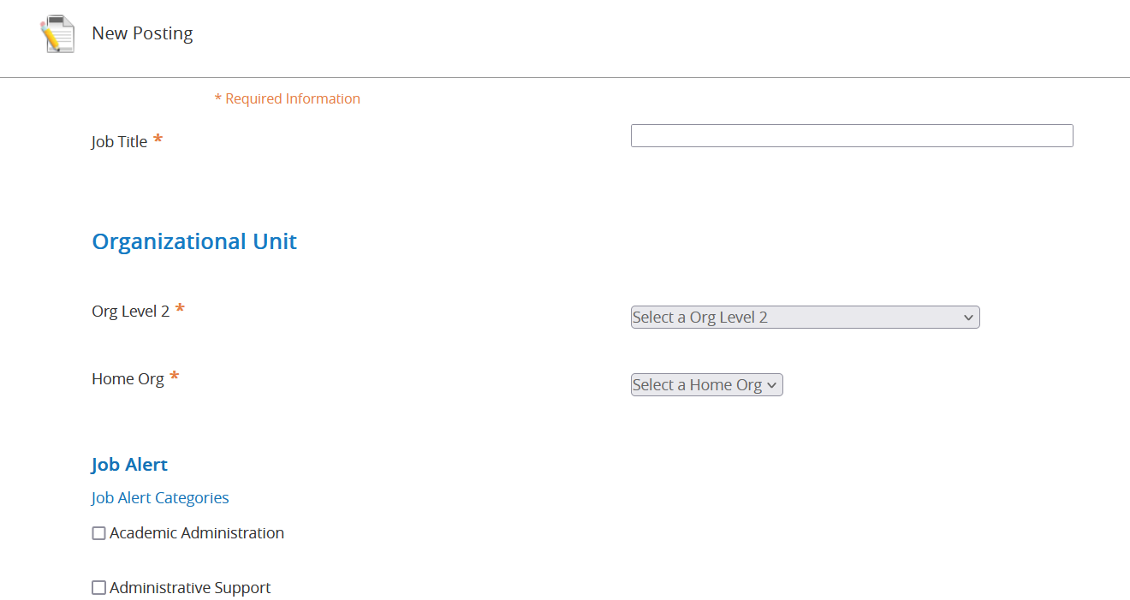  Complete the requested information on the page to include the job title, division, and departmental information. Position title will be Postdoctoral Scholar. Job Alert will be Postdoctoral Scholar and any other category that may apply.
8 | Applicant Workflow
8 | OPA does not recommend this feature. If you choose to use the Reference Feature, select Interviewed – Pending References from the drop-down box on both the Reference Notification and Reference Workflow. You will also select Reference Letter from the Recommendation Document Type.  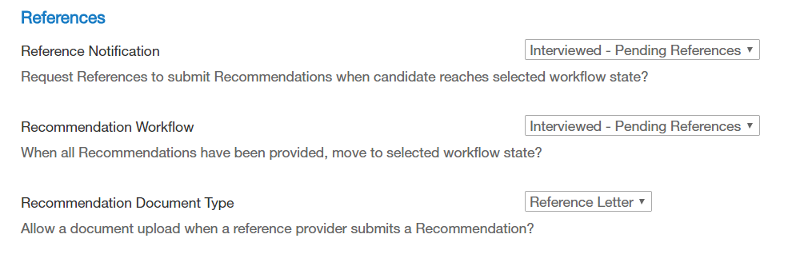
9 | Verify that the Accept Online Applications box is checked.  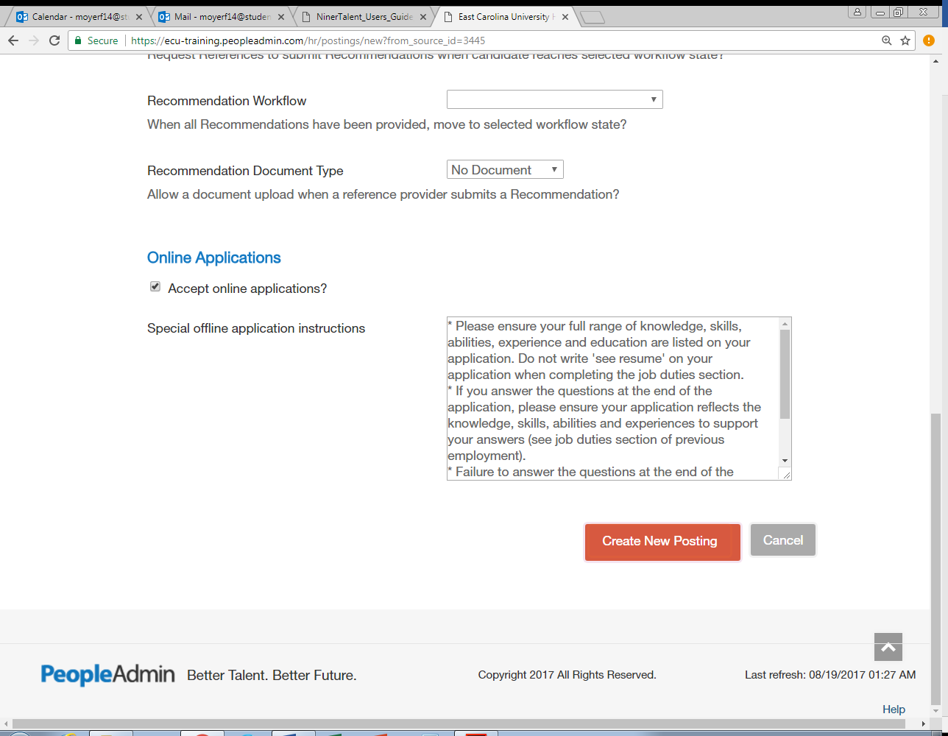
10 | Click Create New Posting (bottom right of the screen).  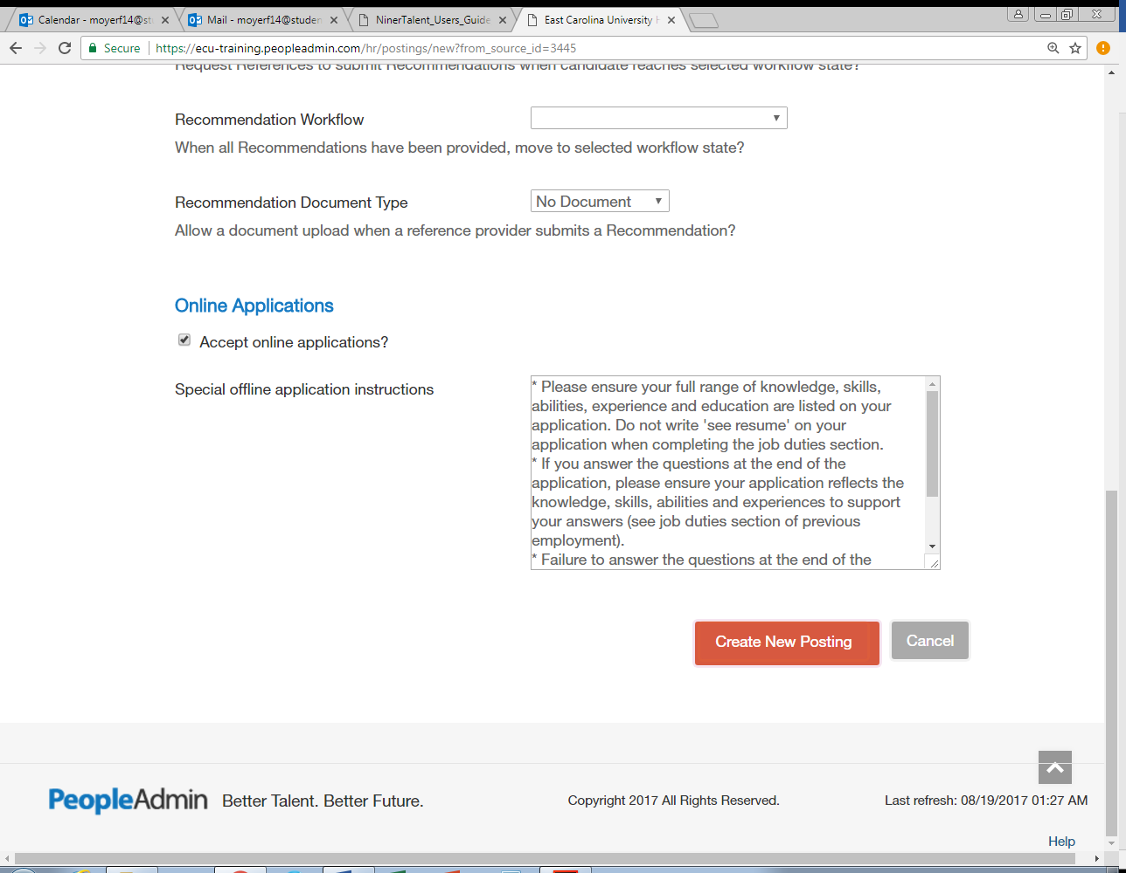  The Editing Posting menu displays.  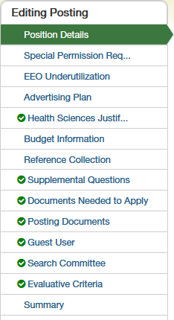
11 | Complete all fields on the Position Details tab following the information below. You will notice that there is instructional text beneath all of the fields. * Indicates required info, but for Postdocs, OPA requires all information be entered as indicated below.  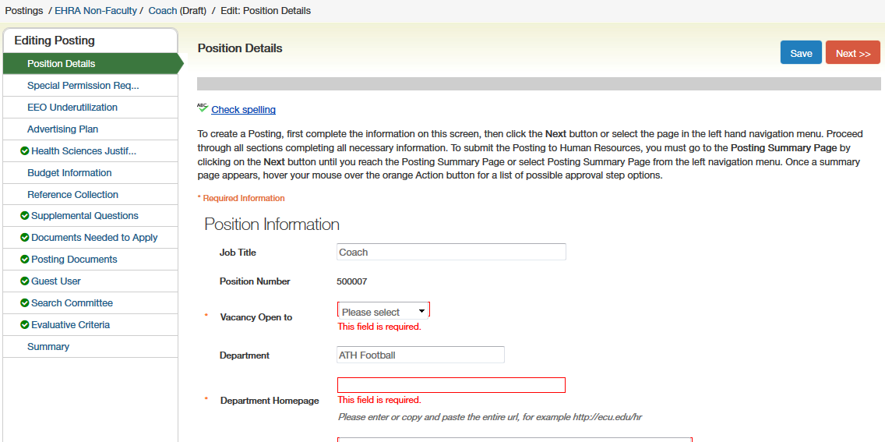  Posting Details  Job Title: Postdoctoral Scholar (pulls in automatically)  *Position Number: PDS-XXXX-00-00  Note: For PeopleAdmin posting purposes only, you will use a Position Number configured with the letters PDS, a dash, then the 4-letter acronym of your department, a dash, then the two numbers of the posting month, a dash, then the two numbers of the current year. For example, if Biology is positing a postdoctoral scholar position in February 2020, the position number in PeopleAdmin posting would be: PDS-BIOL-02-20  *Vacancy Open to: select All Candidates  *Department Homepage: enter your department’s website address  *Advertising Department: select your department  *Division: select your division  *Applicant Reviewer Access: select each name of those who may screen applicants in this field  *Search Committee Chairperson: enter supervisor (mentor) name  Chairperson Phone Number: enter phone number  *Search Committee Members: enter supervisor (mentor) name  *Have all search committee members participated in mandatory search committee training conducted by OED? Select correct answer  Classification Title: Postdoctoral Scholar  *Working Title: Postdoctoral Scholar  *Reason for Vacancy: select New Position or Separation  Date of Separation/Transfer/Promotion: click in box and select date if applicable  Name of employee replaced: enter name if applicable  *Number of Vacancies: enter number of vacancies  *Full Time Equivalent (FTE): 1.0  *Full Time or Part Time: select Full Time  Recruitment Range: $61,008  Note: This must be a minimum of $61,008 and the top of the range would depend on the posting department’s resources. The NIH Postdoctoral Scholar salary scale can be found at: https://grants.nih.gov/grants/guide/notice-files/NOT-OD-23-076.html.  *Position Location (City): Greenville  Position Type: select Postdoctoral Scholars  Job Category: select Postdoctoral Scholars  *Organizational Unit Overview: enter summary of your department  *Job Duties: copy/paste from the SUMMARY OF DUTIES section on the Position Description Form  *Minimum Education/Experience: English Proficiency, Excellent written and oral communication skills, PhD or MD required (may copy/paste from Position Description Form but it must include the previous items listed)  *License or Certification Required by Statute or Regulation: enter only if applicable to the job  Preferred Experience, Skills, Training/Education: copy/paste from the PREFERRED EXPERIENCE section on the Position Description Form  Special Instructions to Applicant: copy/paste the following - To be considered for this position, all applicants must apply through PeopleAdmin and attach their CV or resume, cover letter and names and contact information of 3 references. Appointments are typically for a one-year period. Five years (typically five appointments of one year) is typically the maximum total period that any individual may serve as a Scholar. The University, in its sole discretion has the option to renew or extend any appointment, subject to the availability of funds, past performance evaluations and/or any other lawful reasons. For other information on the ECU Office of Postdoctoral Affairs, please visit our website at: https://rede.ecu.edu/postdoctoral/  Job Open Date: click in box and select date  Open Until Filled: at the department’s discretion  Job Close Date: click in box and select date (minimum of 7 days)  Initial Screening Begins: click in box and select date (will be the closing date or 7 days after posting if posting as open until filled)  *Essential Job Requirements: 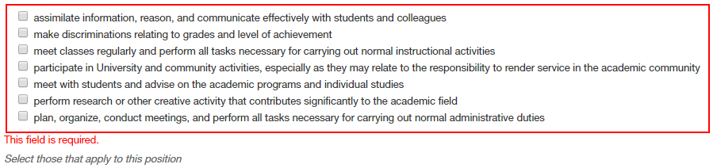  *Physical Requirements: 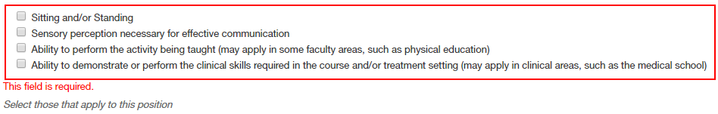  Additional Requirements: enter if applicable  Terminal Degree: enter PhD, MD, DMD or DDS or a combination of these degrees  Is this degree required or preferred? Select Required  Rank Level: select Not Applicable  Appointment Term: select 12-month  Does This Recruitment Qualify for the Modified Search Process: select Yes-Postdoctoral Scholar position.  Desired Selection Date: click in box and select date
12 | Click Save.
13 | Click Next. The Special Permission page displays. Select No.  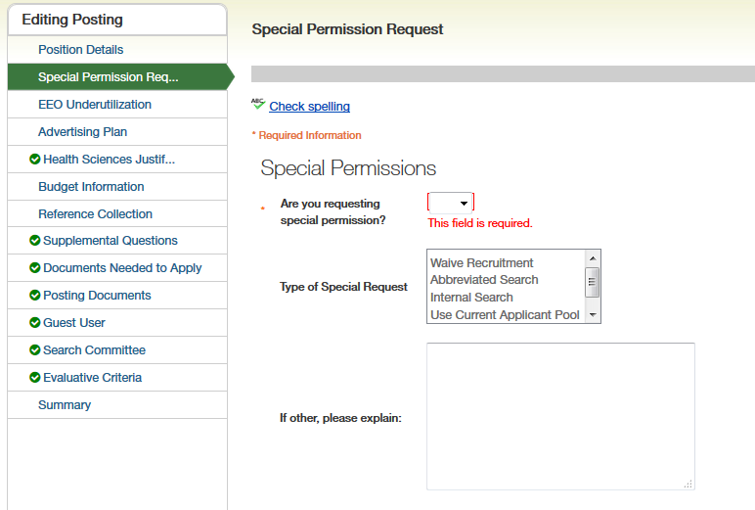
14 | Click Save.
15 | Click Next. The EEO Underutilization page displays. Select No.  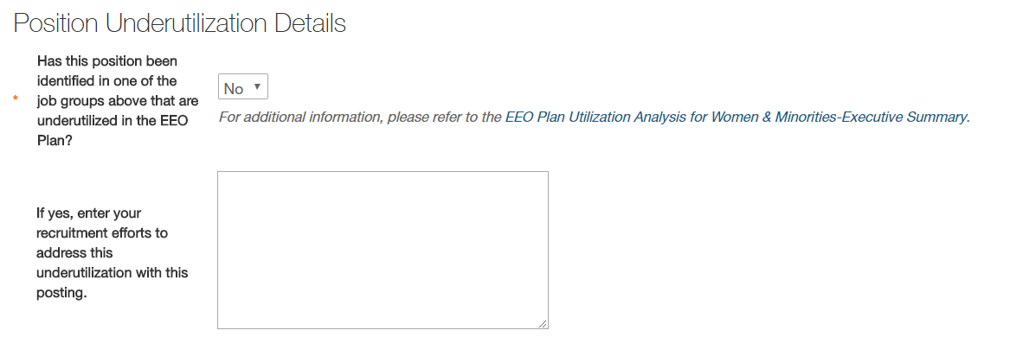
16 | Click Save.
17 | Click Next. The Advertising Plan page displays. Select all free advertising sites and select the job categories under those sites. In the Professional conferences & other efforts that will be made to attract a diverse applicant pool box please list any professional conferences, listservs, etc. that will be used.  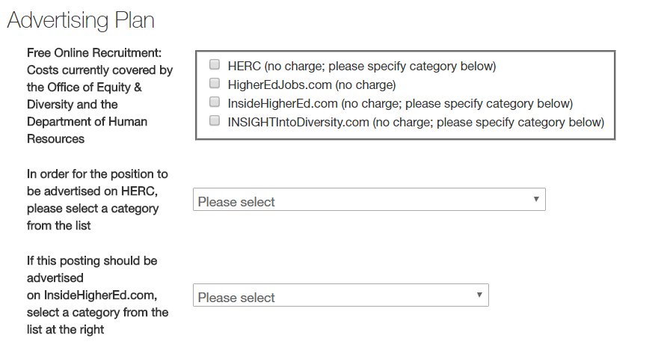  Note: Any external postings of this position must contain a job description and qualifications that are taken directly from the Position Description Form and the corresponding PeopleAdmin posting (i.e. listservs, journals or professional organizations) and must refer the applicant to the ECU Job Postings site: https://ecu.peopleadmin.com/
18 | Click Save.
19 | Click Next. The Health Sciences Justification page displays  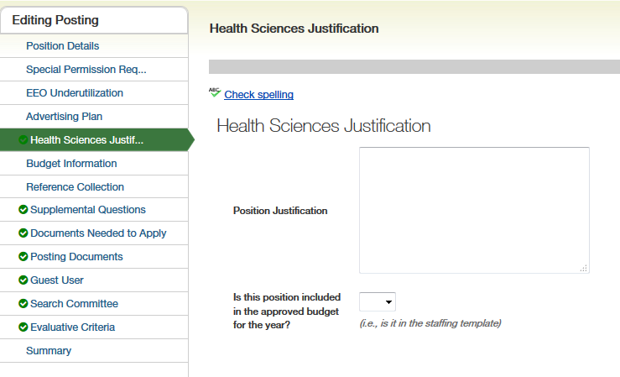  Complete the Health Sciences Justification page if the unit if required by the division.
20 | Click Save.
21 | Click Next. The Budget Information page displays. Click Add Budget Summary Entry. Enter all budget information from Position Description Form.  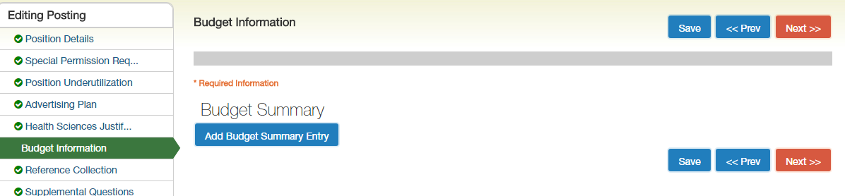
22 | Click Save.
23 | Click Next. The Reference Collection page displays. OPA does not recommend this feature.  If you wish to set up reference collection through PeopleAdmin, please complete all of the fields on this page.  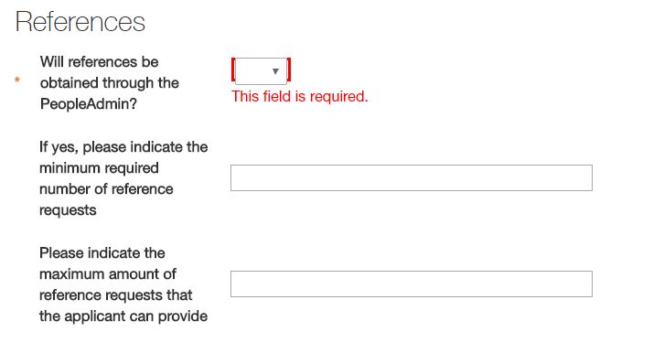
24 | Click Save.
25 | Click Next. The Supplemental Questions page displays. This is at the discretion of the department.  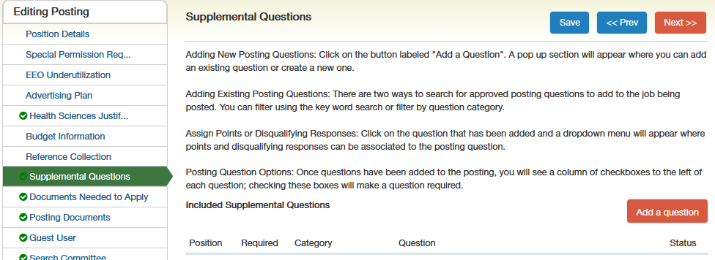  If you wish to create or add supplemental questions, please select from approved questions or submit a question for approval.
26 | Click Save.
27 | Click Next. The Documents Needed to Apply page displays. Select Curriculum Vitae/Resume, Cover Letter, List of References as Required.  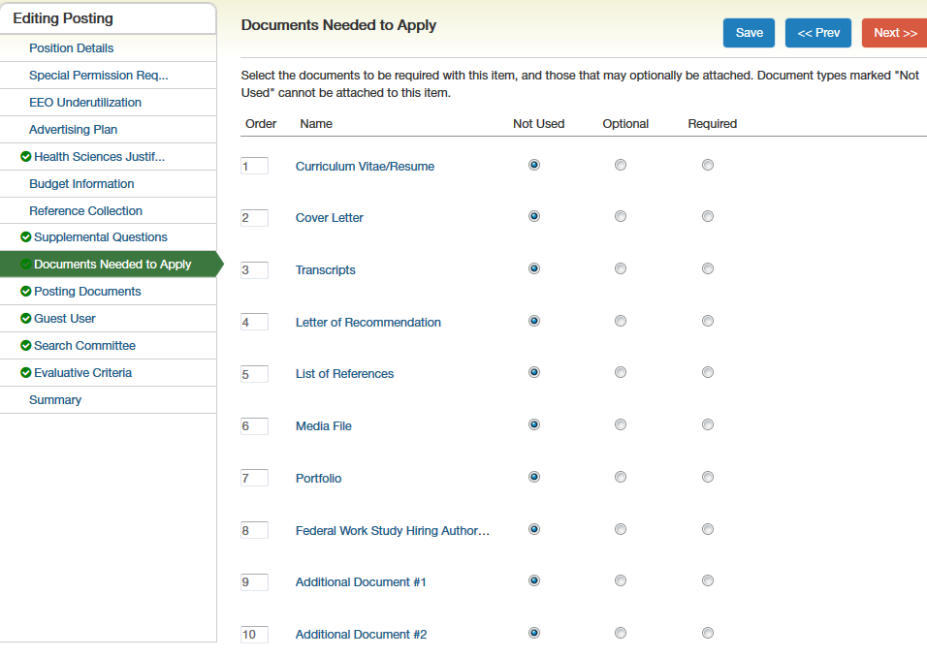  Note: The default is Not Used. You must indicate if the document is required or optional.
28 | Click Save.
29 | Click Next. The Posting Documents page displays. For document type Additional Document, click actions and upload the Position Description Form. This will be viewable by HR, Budget and the Office of Postdoctoral Affairs for approval purposes.  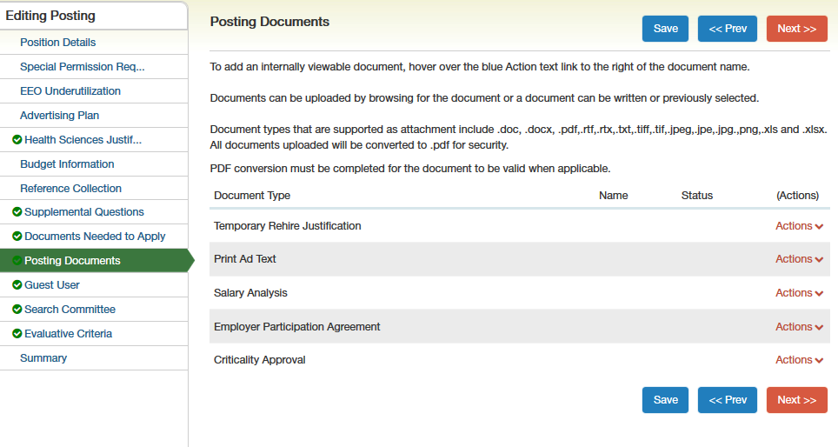
30 | Click Save.
31 | Click Next. The Guest User page displays.  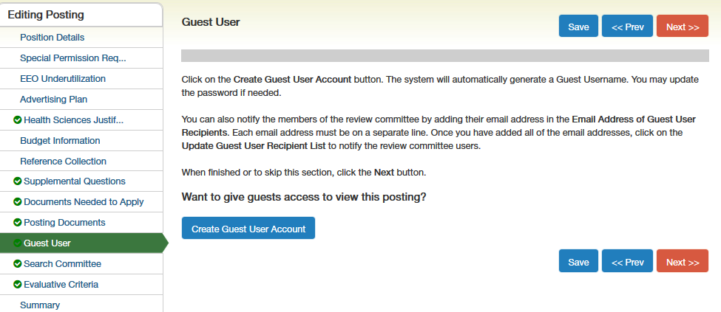  If you DO NOT wish to create a Guest User, click the Search Committee tab.  If you wish to create a Guest User, see the Create a Guest User instructions below.  Note: This feature is only used for search committee members external to ECU.
32 | Click Save.
33 | Click Next. The Search Committee page displays.  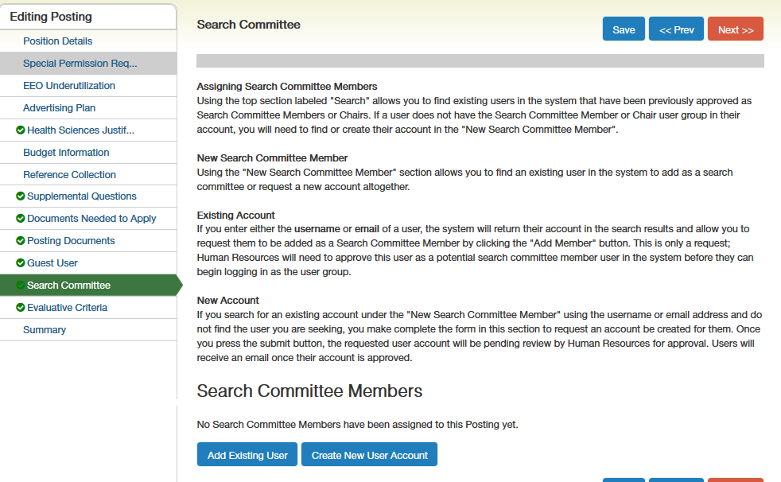  Complete the Search Committee page clicking Add Existing User. Adding Search Committee Members in this page provides access as a Search Committee Member where they may log in and view the posting, applicants, and all application materials.
34 | Click Save.
35 | Click Next. The Evaluative Criteria page displays. This is at the discretion of the department.  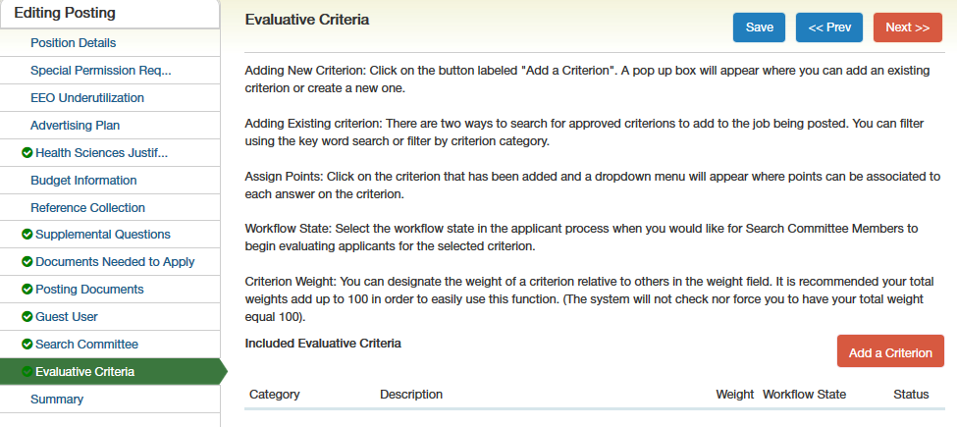  Complete the Evaluative Criteria page as necessary.
36 | Click Save.
37 | Click Next. Review the information for accuracy.
38 | Click Take Action on this Posting. The Workflow Actions menu displays.  This will give you the option to route through the appropriate areas for approval. Click the appropriate approver by selecting the Workflow Action based on your Division protocol. If your College and/or Division does not choose to approve Postdoctoral Scholar PeopleAdmin postings for Level 1 or Level 2, submit to the next approval type following Level 2 which will be budget. For budget select the appropriate approver name based on funding type.  BUDGET GROUPS ROLES  16065 State: 111XXX (Heather Taylor & Tim Morris & Dawn Quist)  16066 State: 112XXX Tim Morris & Heather Taylor & Dawn Quist  Non-State (ITF/ECUP): 12XXXX, 14XXXX, 2EXXXX, 23XXXX, 24XXXX, 25XXXX, 27XXXX, 31XXXX  (Yolanda Hill/ Laura Fanning/ Dawn Quist)  Foundation: EXXXX, AXXXX (Mark Sarfo/ Heather Wiggins/ Brittany Stockstill)  Medical Foundations: MXXXX (Joel Stocks/ Mandy King)  Sponsored Awards: 21XXX,28XXX (Karen Mizzelle/ Steve Ayers/ Janice McGowan)  * Non-State Funds Salaries $150,000 - $250,000 will require approval (AF Vice Chancellor Stephanie  Coleman)
39 | Click Submit.

Complete the Guest User Account
Create a guest account for search committee members.
Step | Action
1 | Select the Guest User tab. The Guest User page displays. Click Create Guest User Account.
2 | Verify the username and password. Update or change the password, if needed.
3 | Enter the guest user’s email address.  Any search committee members who are NOT ECU Faculty and Staff will need access as a Guest User.
4 | Click Update Guest User Recipient List.  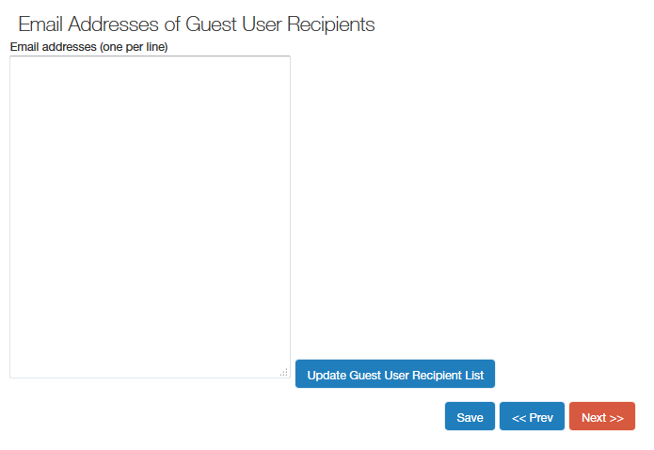
5 | Click Next to move to the Summary tab.

Review the Applicant Pool
The applicants may be reviewed beginning on the initial screening date, regardless of whether the position is open until filed or has a close date. The Applicant Reviewer will update the statuses based on recommendations from the Search Committee.
Step | Action
1 | Log in to People Admin with your PirateID.  Change the module to Applicant Tracking System, if needed.
2 | Please note that you do not have to manually change your default user group as you will automatically be redirected when selecting the position from your Inbox.  You may continue to manually change your default user group using the instructions provided below.  Change the Default User Group (top right corner) on your home page to Applicant Reviewer.
3 | The page should automatically refresh. A blue confirmation message will appear at the top of the screen.  Note: The menu may change based on your default settings.
4 | Postings that have applicants ready for review will display in your inbox. Click on the Job Title which will open up the posting.  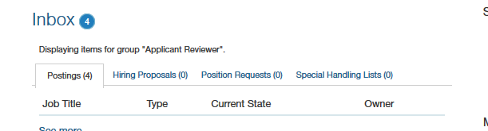
5 | Click the Applicants tab.  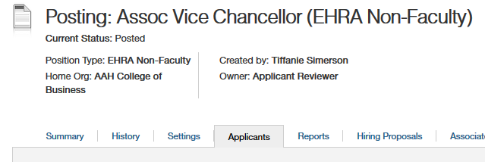  The Posting displays all applicants for that posting.  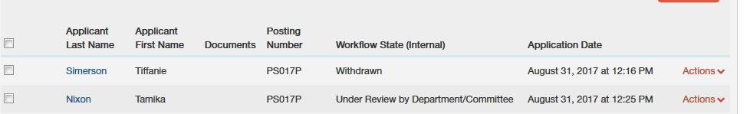
6 | Click the name of an applicant to review. The job application displays.
7 | Option 1. To view an individual application, click on the Applicant’s Name to open the application or click the checkbox to the left of the Applicant’s Name and hover over the Action button to the right and select view application.  To view supplemental documents, scroll to the bottom of the page and select View under Combined Document.  Option 2. To view multiple applications at once, click the checkboxes to the left of the Applicant’s Names, then hover over the Action button at the top and select Download Applications as PDF.
8 | Click Take Action on Job Application.
9 | Click Next at the top of the page to move to the next applicant.  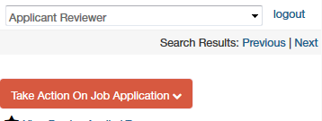
10 | Follow these steps to review all additional applicants.
11 | For applicants not selected:  Option 1. To move them in the workflow individually, click the checkbox to the left of the applicant’s name, hover over the Actions button, then click Move in Workflow. On the next screen, from the dropdown box, select the appropriate Workflow State and the Reason for Non-Selection from the dropdown box that appears on the right.  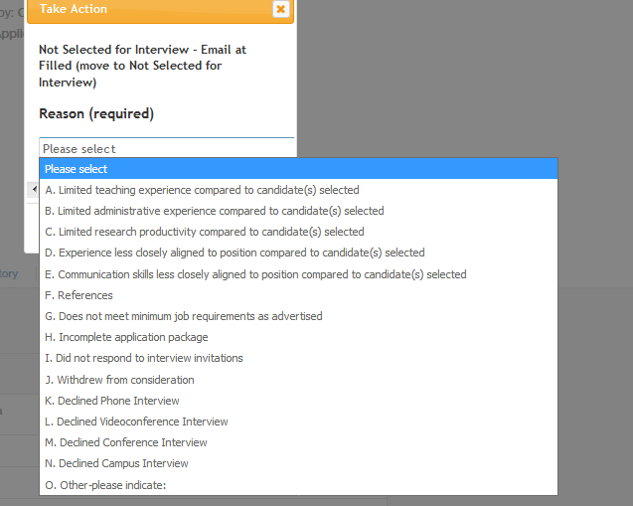  Option 2. To move multiple applicants, select the checkboxes to the left of the applicant’s names, hover over the Actions button, then click Move in Workflow. You can change the status for all applicants or change them individually.
12 | Once interviews for the position have been completed, you will update the applicants’ statuses as appropriate. Using the instructions above.

Take Action on Job Applicant Status
Choose 1 of 5 actions.
Workflow Action | Description
Selected for Interview | This option will be used for applicants who are selected for interview.
Not Interviewed, Not Selected – Email at Filled | Document non-selected applicants’ skills compared to selected candidate.
Interviewed Phone, Not Selected | Document non-selected applicants’ skills compared to selected candidate.
Interviewed Videoconference, Not Selected | Document non-selected applicants’ skills compared to selected candidate.
Interviewed Conference, Not Selected | Document non-selected applicants’ skills compared to selected candidate.
Interviewed Campus, Not Selected | Document non-selected applicants’ skills compared to selected candidate.
Interviewed – Pending References | This option will be used if you selected the reference feature on the posting. Changing the candidate to this workflow state generates as email to the references provided by the candidate to submit a reference letter.
Interviewed – Candidate of Choice | Candidate selected for the position.

Create the Hiring Proposal
The Create Hiring Proposal action moves the successful candidate into a vacant position.
Note: This procedure is the same regardless of employee type or user role.
Step | Action
1 | From the Applicants tab, choose the candidate.
2 | Click the appropriate Start Hiring Proposal. The Selected Position Description screen displays showing all positions within your department.  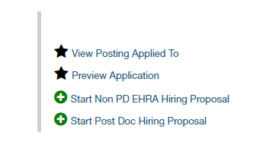
3 | The Hiring Proposal form displays. Enter all information outlined below.    Hiring Proposal Tab  Employee Class: Y2 – Post Doctoral Scholar  Leave Category: LY – Post Doctoral Scholar  Home Department: select appropriate department  Current Hire Date: enter date Postdoc to begin work (This date should be on a Monday or Tuesday only if Monday is a holiday where University is closed.)  Position Number: PDS-XXXX-00-00  Banner Position Number: Y00001  Job Begin/Effective/Personnel Date: enter same date as Current Hire Date  Job Employee Class Code: Y2 – Post Doctoral Scholar  Timesheet Org: select appropriate department  Supervisor Banner ID: enter supervisor Banner ID  Job Location: select appropriate department  Job Change Reason: PA045 – New Hire Temporary  Annual Salary: enter salary amount listed on approved Position Description Form  FTE: 1.000  Contract Type: P-Primary  Mailstop: select appropriate mailstop  Pays: 24  Factor: 24  **Job Effective End Date: this field must be entered as contracts are only for 1 year  **Job Personnel End Date: this field must be entered as contracts are only for 1 year  Click Next  Budget Tab  Add any relevant budget comments.  Labor Dist Effective Date: enter begin date  Click Add Budget Details Entry  Enter FOAP from approved Position Description Form  Project Code: 1.0  Percent: 100.00  Click Add Salary Entry  Enter Annual Salary  Click Next  Compliance Report Tab  Answer both questions appropriately  Click Next  Hiring Proposal Documents  Upload any relevant documents  Click Next  Review the Hiring Proposal Summary to ensure all information is entered accurately.
4 | From the Summary tab, click Take Action on Hiring Proposal.  Click the appropriate approver by selecting the Workflow Action. Postdoc Hiring Proposals should be routed in the following order:  - HR Employment (initiator will click this option)  - OED  - Budget  BUDGET GROUPS ROLES  16065 State: 111XXX (Heather Taylor & Tim Morris & Dawn Quist)  16066 State: 112XXX Tim Morris & Heather Taylor & Dawn Quist  Non-State (ITF/ECUP): 12XXXX, 14XXXX, 2EXXXX, 23XXXX, 24XXXX, 25XXXX, 27XXXX, 31XXXX  (Yolanda Hill/ Laura Fanning/ Dawn Quist)  Foundation: EXXXX, AXXXX (Mark Sarfo/ Heather Wiggins/ Brittany Stockstill)  Medical Foundations: MXXXX (Joel Stocks/ Mandy King)  Sponsored Awards: 21XXX,28XXX (Karen Mizzelle/ Steve Ayers/ Janice McGowan)  * Non-State Funds Salaries $150,000 - $250,000 will require approval (AF Vice Chancellor  Stephanie Coleman)  - PostDoc Approver – Hiring Proposal will not be approved/finalized until all required documents on the departmental checklist are received by the OPA.
5 | Add comments and click Submit.  After OED approval, you will receive an email notification that verbal negotiations can begin. Forward this email to OPA.

Extend an Offer of Employment
Refer to your departmental checklist provided by the OPA for the next steps to extend an offer of employment.

